what is climate change  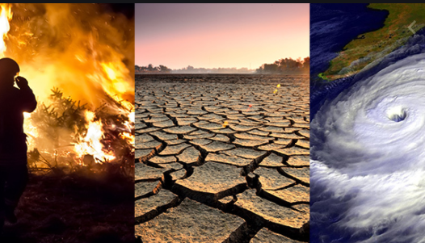Defining climate change  - Climate change includes a change in the patter of weather over a long period of time.  - It also includes various changes in ocean and ice sheets as well as changes in the land surfaces.  - Climate change is responsible for various observable effects on the environment. |  | Who We Are  About Us  We are a group of students concerned on the effects of climate change on housing and the possible solutions.  Contact us  Email:housingsolns@gmail.com  Contacts:  Resource Links  https://en.klimatilpasning.dk/sectors/buildings/climate-change-impact-on-buildings/#:~:text=Buildings%20can%20be%20vulnerable%20to,climate%20and%20reduced%20building%20lifetime.  https://www.researchgate.net/publication/5501670_Implications_of_Global_Climate_Change_for_Housing_Human_Settlements_and_Public_Health  https://www.yourhome.gov.au/housing/adapting-climate-change  Climate Change and Housing  (Climate Change) |  |  | 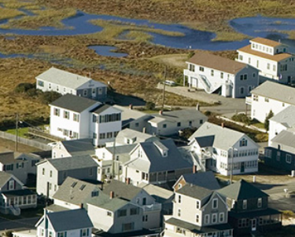  CLIMATE CHANGE  Climate change and Its effects on Housing
Why we should worry  - Collapse of buildings poses a major risk to to the safety of the occupants.  - Flooding due to chnages in sea levels can lead to various health issues.  - Change in climate also reduces the space available for costruction of houses which can lead to congestion in some places.  - Flooding or soil erosion can limit proper lighting and water supply required in different houses.  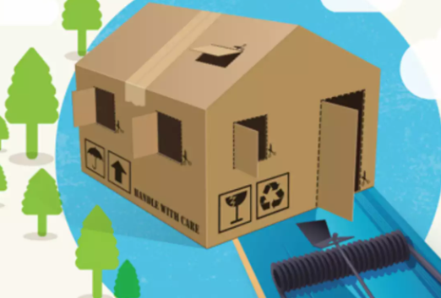 |  | Effects of climate change on housing  - Houses are on the risk of collapse and damage due to strong storms change or heavy snowfalls.  - Climate change affects the durability of materials used in constraction of buildings.  - Buildings along the major coatslines are in danger of seepage or collapse when the sea levels change.  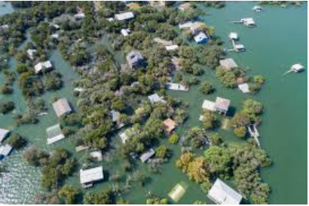 |  |  | Actions to take  - Opting for renewable sources of energy like solar energy which is not easily impacted by the effects of climate change like flooding.  - Proper heating and ventilation of houses to cater for both the low temperatures as well as rise in temperatures after changes in weather.  - Adopting to multifamily housing and controlled settlement in areas likely to be affected by the rise in sea levels.  - Providing affordable housing in areas for relocating people who may be affected by the change in climate.  - Use of more durable building materials which are less affected by high temperatures or heating.

